Off Campus Housing Request User Guide
This application is used to submit a request living off campus for the request year. Completing this form will help the Residence Life Office consider your wish to live off campus in the coming year. Submitting this form does not guarantee that you will be allowed to live off campus. If you have a medical and/or psychological condition and would like to request special consideration in the housing assignments process, please review the information available on the Housing Accommodations Website.
The menu choices:
Residence Life
Clicking the “Residence Life” menu choice we redirect you to the Residence Life landing page.

Off campus housing request home
Clicking the “Off campus housing request home” menu choice will bring you to the main landing page for the “Off Campus Housing Request” application.

Logout
Clicking the “Logout” menu choice will log you out of the application and will require you o log back in to see the application.

The off campus housing request home page
This is the main landing page for the application. To complete it you need to select the year you wish to live off campus, then click the "Check that fields are complete" button.
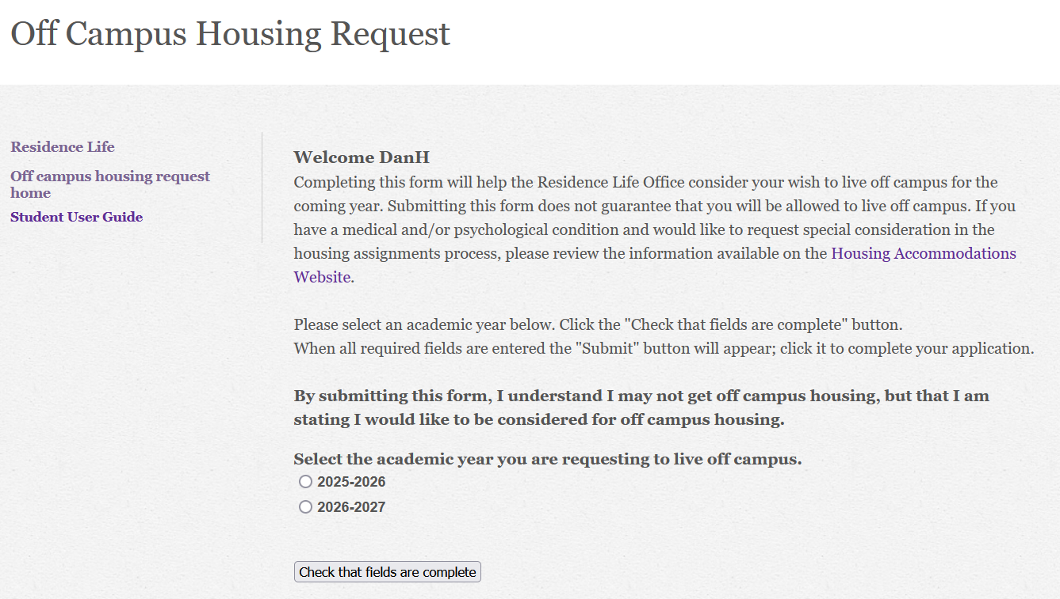
If you have selected a year then the “Submit” button will appear. Clicking the “Submit” button will finalize your request.
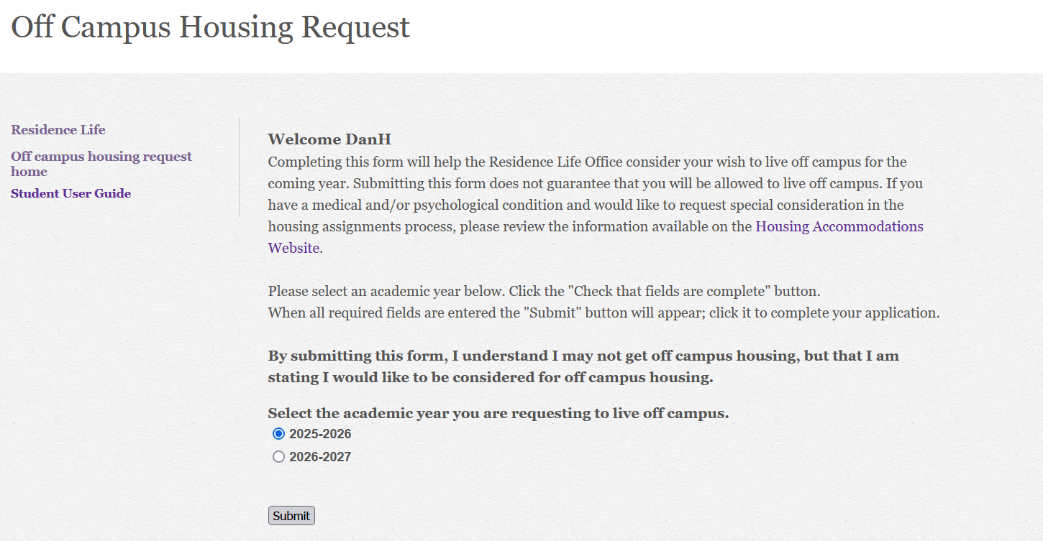
The application will bring you to the thank you page.
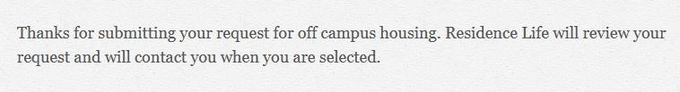
The application will then email you a confirmation of your request and an email to the Residence Life office notifying them of your request.
When you submit your request, the application will check to see if you have already submitted a request for that year and if you have it will return the following error.
