RA views for Student Room Checkout
These instructions are to walk you through the student checkout process of the Student Room Checkout application.
The shortcut to the application is below https://crnl.co/StudentRoomcheckout.
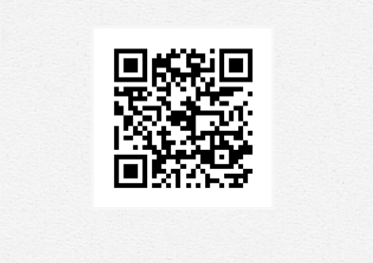 (http://crnl.co/StudentRoomCheckout)

Landing page is the main index page for the application, make sure the cursor Is in one of the fields so your input will take.
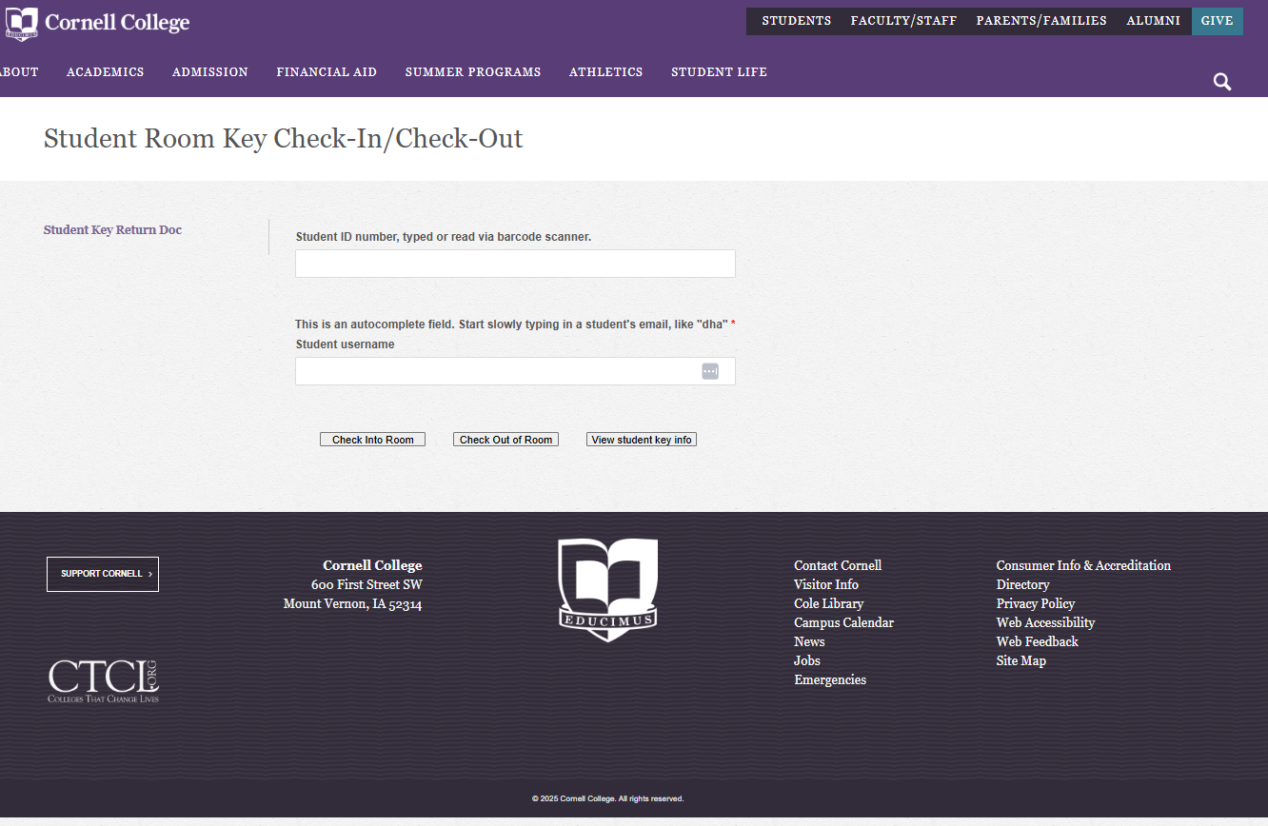

You need to input the student into the application. You can do that a couple different ways. You can enter student ID, you can either typed it in or scanned:
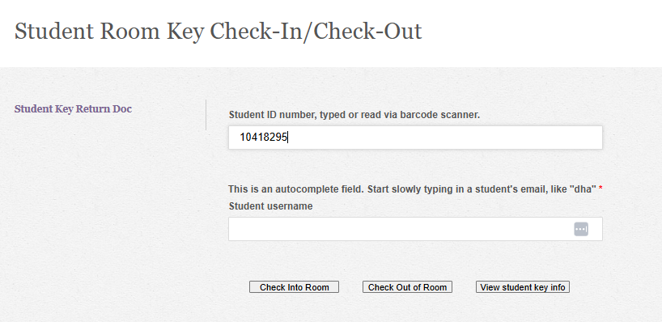
Optionally you can start typing in a user name and the application will put up a dropdown list of names for you to select from:
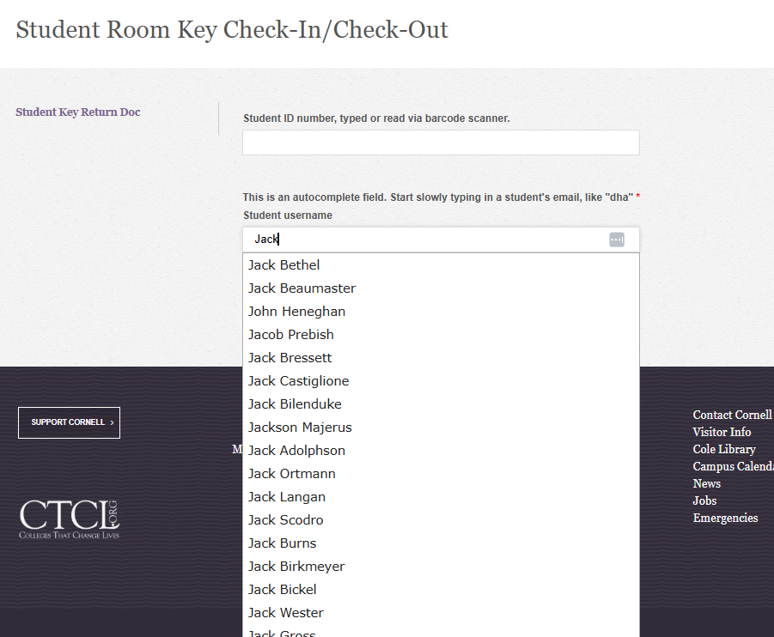
Select from the dropdown list to fill in the username.
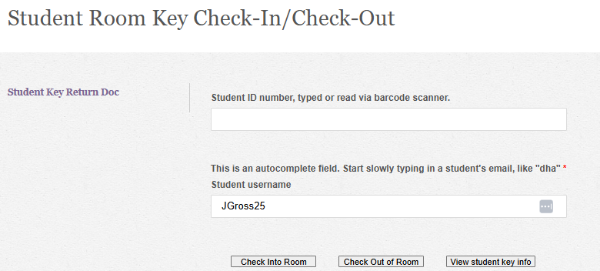
There are three (3) options from here. 1. Click “View student key info”, this will bring up the “View Student Key Information page below. There you will get the review form. Make sure the student on the screen is the student you are collecting the key for. 2.Click “Check Out” button to go directly to the Key drop off receipt confirmation page, next page in the document. 3. Click “Check In” which is covered in another document.
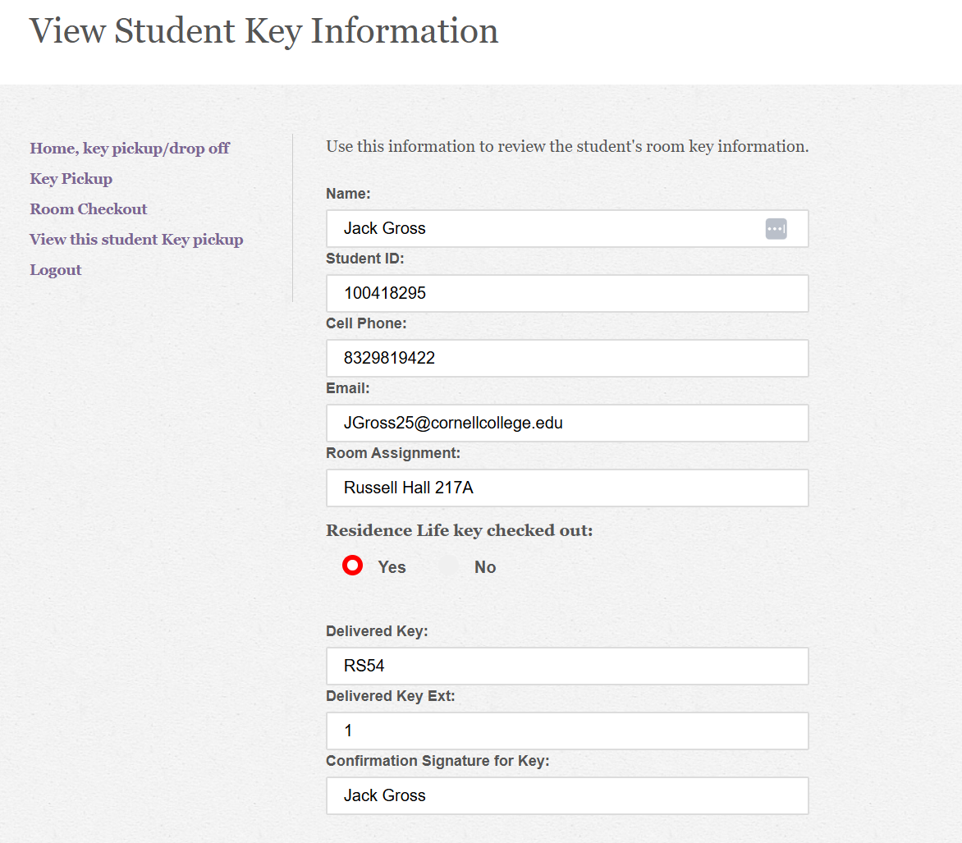
Click the “Room Checkout” in the left navigation menu.
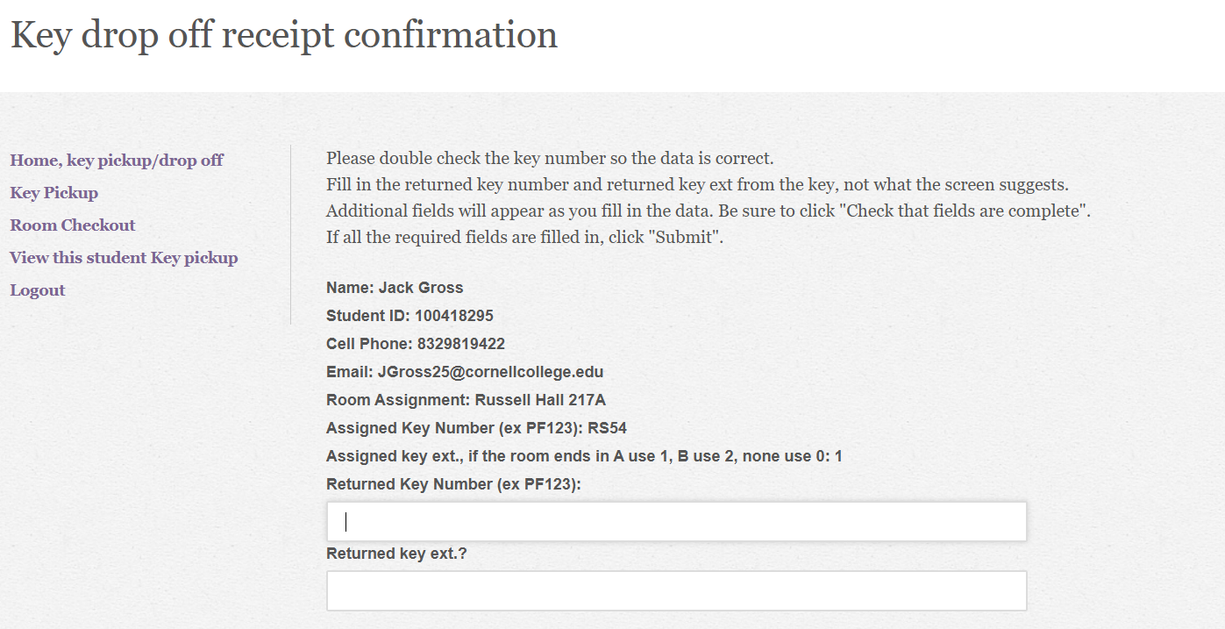
Please double check the key number so the data is correct. Fill in the returned key number and returned key ext. from the key, not what the screen suggests. Additional fields will appear as you fill in the data. Be sure to click “Check that fields are complete. If all the required fields are filled in, click “Submit”.
You can either scan/type in your student ID.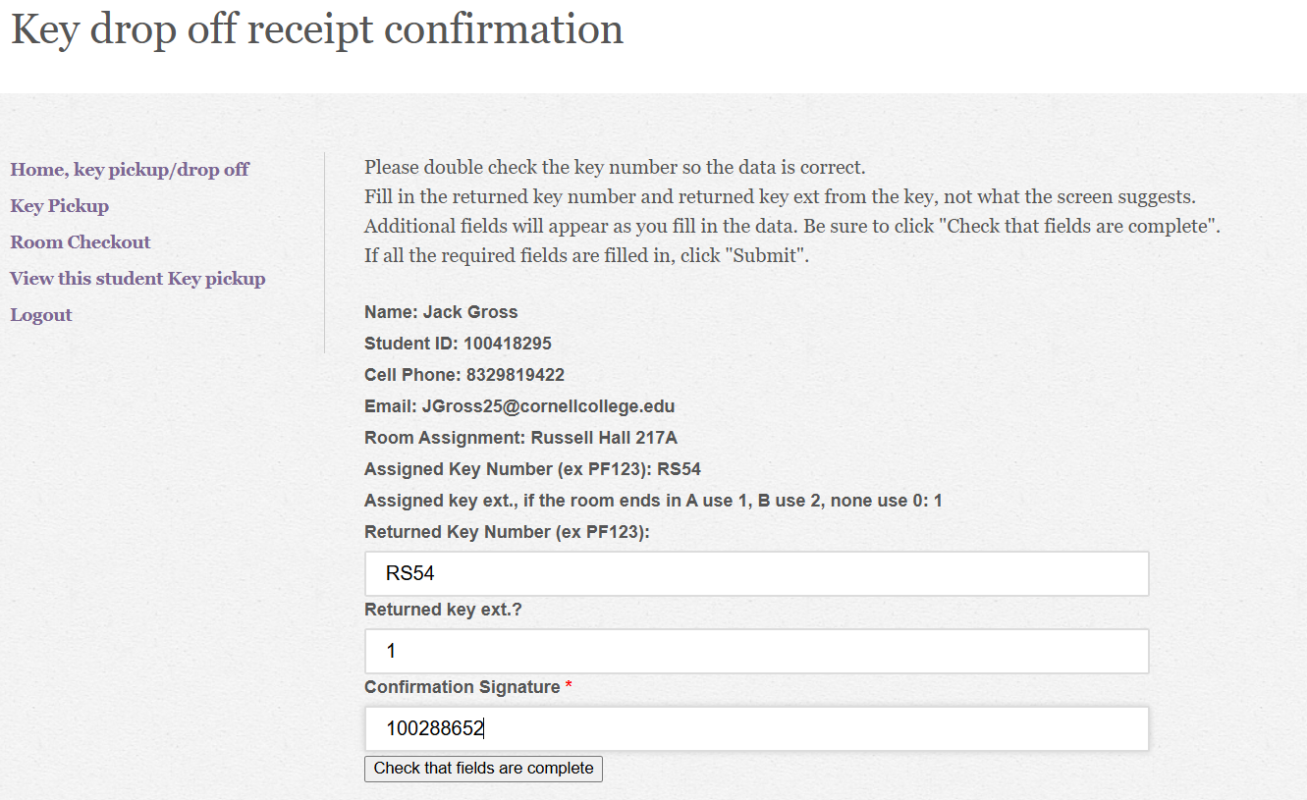

Or type in your name
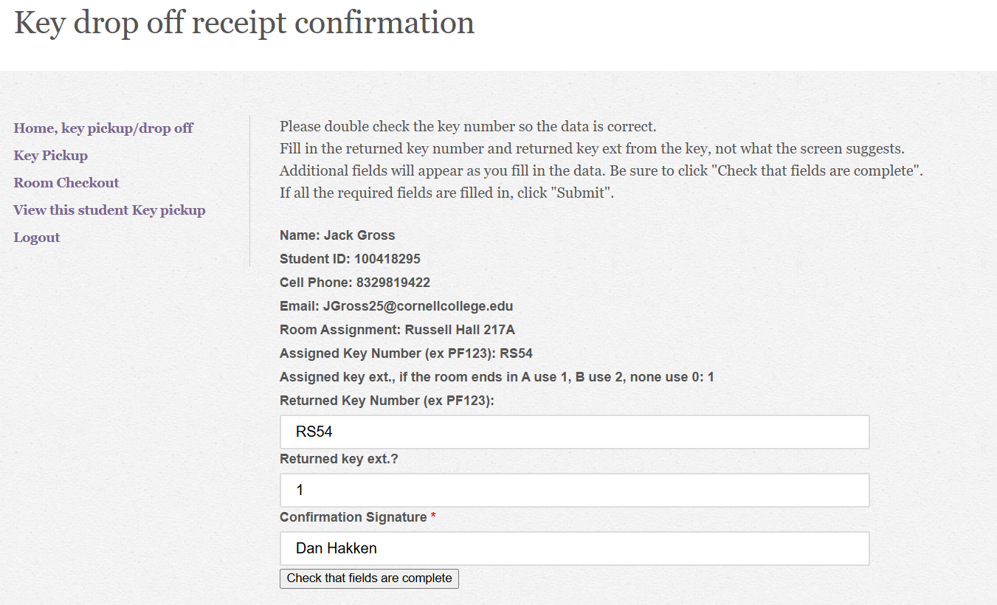
Click “Check that fields are complete”
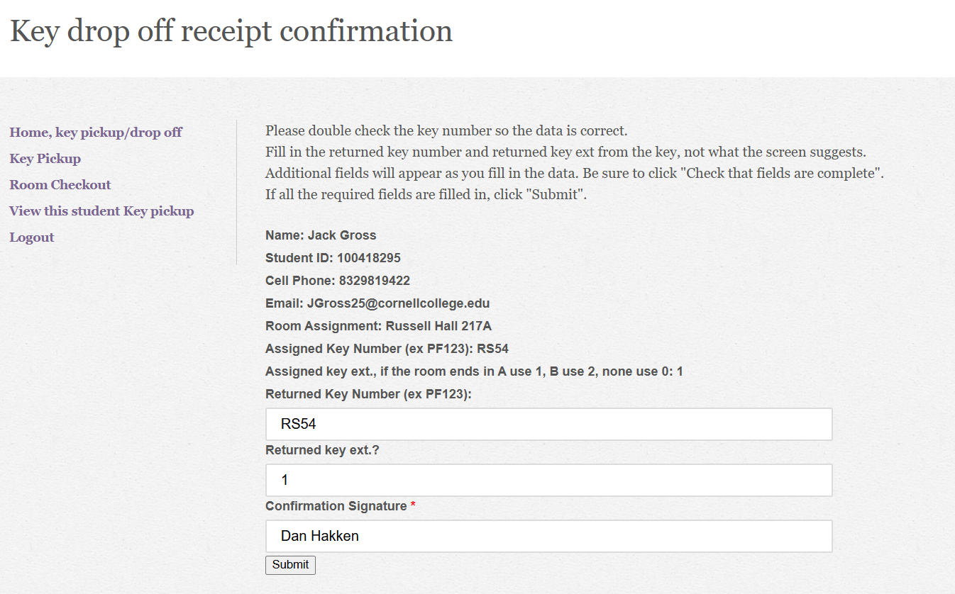
Then click “Submit” to save your input and return to the “View Student Key Information”
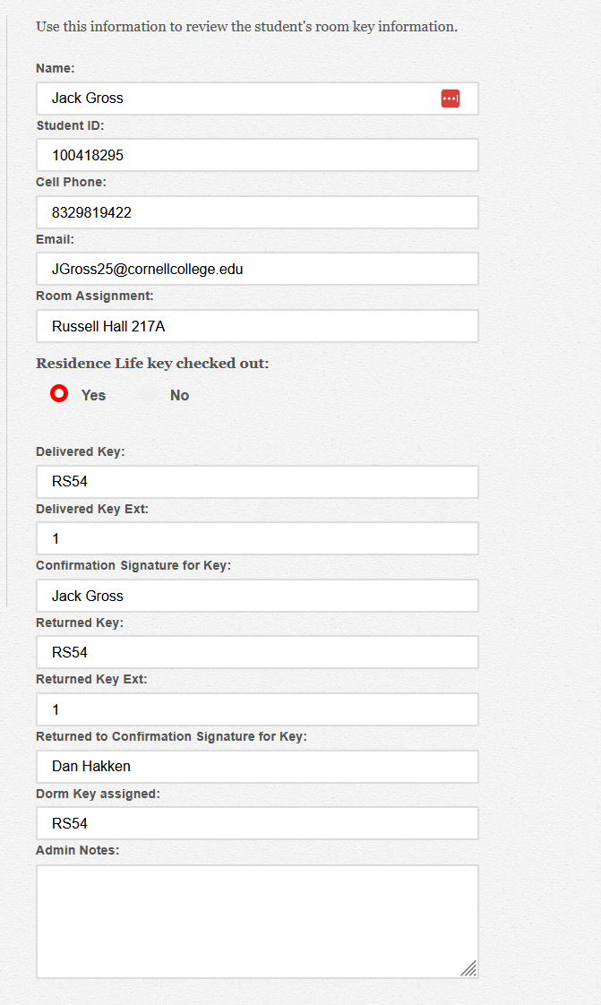
Click the “Home, key pickup/drop off to start a new return.
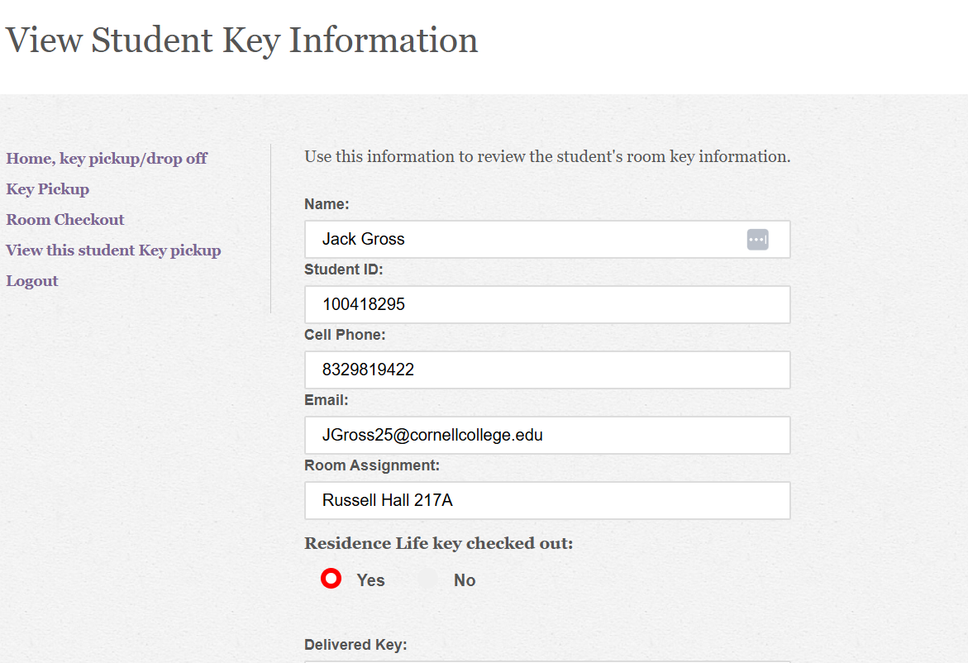
Start the next student.
