Omnibus Application User Guide

To complete the omnibus application:
- Log in to the application and fill in all fields.
- There is no save option. Please fill in all fields and submit.

Late Registration Changes
- If you want to drop a course ​after the 15th day deadline​, select ​Drop Course​ in the left navigate.
- If you want to request course registration changes ​after the 3rd day of block​ and before the 15th day of the block​, from the “Select a type” dropdown select either “Drop Course” or “Change Course”.
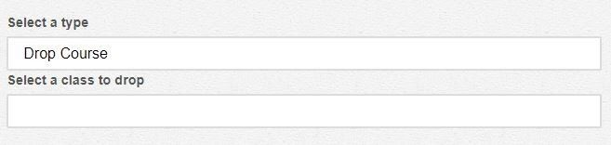
- If you select “Drop Course” you will need to select the class to drop from the” Select a class to drop” drop down, then select your returning block from the “First block you plan to return for” drop down.
- If you select “Change Course” you will need to select the class to add from the “Select a class to add” drop down, then select the class to drop from the” Select a class to drop” drop down.
- If you are changing or dropping the course on the advice of your instructor, select Yes. and submit their statement. ​Accepted file types include ​.txt, .csv, .pdf, .jpg, .doc, .docx. ​Otherwise, the file will not be uploaded. If not, select No.
- Add your reasoning for changing or dropping the course (e.g., course is not part of major or minor requirements) and add any additional comments you may have.
- Lastly, sign the application and hit ​Submit​.

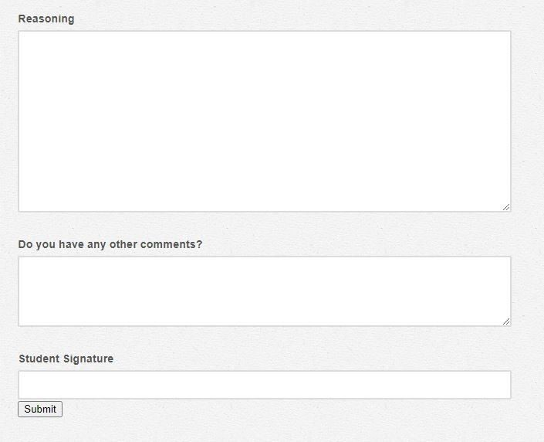

- Once the application has been submitted, you will receive a confirmation email where you can also view the progress of your application. An email will also be sent out to the registrar, your advisor, financial aid, and the instructor of the course you are changing/dropping.

Drop a Course
- For a day 15 drop go to https://www.cornellcollege.edu/registrar/add_drop/ form
- Fill out this application if you would like to drop a course for one of the following reasons:
  - Drop a course after 15th day (W)
  - Health or family emergency reasons (WH)
  - Drop a course on the 15th day while you are on probation (W)
- Select the Type of Drop​ dropdown and choose a reason for dropping a course​

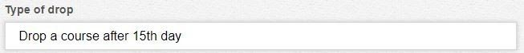
- Each category will populate different fields. Please submit all required information. If you have any questions regarding the application, email the Registrar at registrar@cornellcollege.edu
- Each category will have an additional comments field.
- Lastly, sign the application and hit Submit​ .​
- Once the application has been submitted, you will receive a confirmation email where you can also view the progress of your application. An email will also be sent out to the registrar, your advisor, financial aid, and to any faculty/staff member related to the application you are sending.

Late BSS Proposal
- More information about the Bachelor of Special Studies (B.S.S.​ ),​ can be found in the catalogue.
- If you have missed the deadline, fill out this form and state your reasoning.
- Upload your prospectus with the petition. Accepted file types include ​ .txt, .csv, .pdf,​
.jpg, .doc, .docx. Otherwise, the file will not be uploaded.​ ● Add any additional comments you may have.
- Lastly, sign the application and hit Submit​ .​
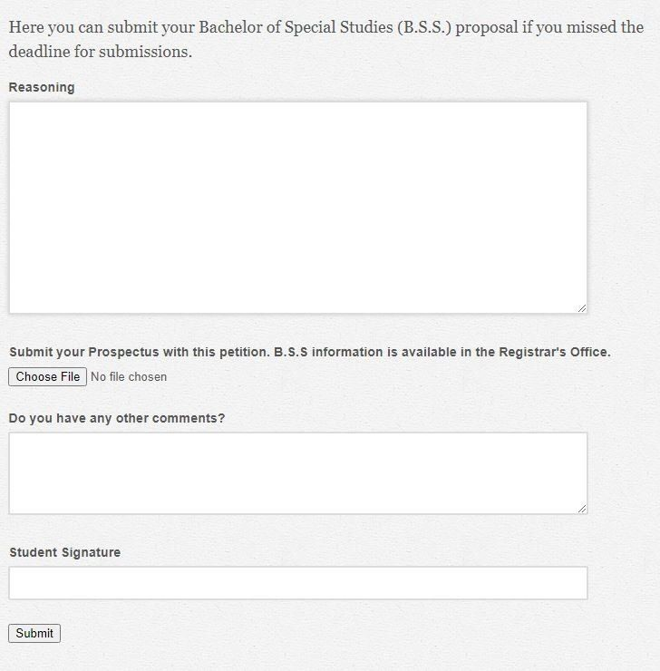
- Once the application has been submitted, you will receive a confirmation email where you can also view the progress of your application. An email will also be sent out to the registrar, your advisor, financial aid, and to the Academic Standing Committee.

Request to Take a Block Off
- Please schedule an appointment with the Financial Ai​ d office to discuss how dropping a​ course will affect your financial aid.
- The application will include the number of courses you have completed. Use this as a guide before you create your plan to be able to graduate in four years.

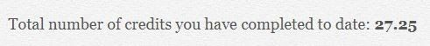

- Select the Dropping Block ​ drop-down and choose the course you want to request off.​
- If you need to take more than a block off, please contact the Registrar at registrar@cornellcollege.edu.​

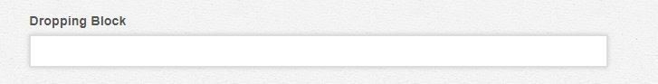
- Please summarize your plan to maintain progress to be able to graduate in four years and add any additional comments you may have.
- Lastly, sign the application and hit Submit​ .​
- Once the application has been submitted, you will receive a confirmation email where you can also view the progress of your application. An email will also be sent out to the registrar, your advisor, financial aid, and to the and the instructor of the course you are requesting to take a block off.

Other
- If you want to submit a petition that does not fall under any of the given categories (e.g., graduate with fewer courses outside any single department), select Other​ .​
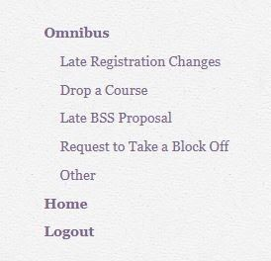

- State your reasoning for submitting this form and add any additional comments you may have.
- Lastly, sign the application and hit Submit​ .​
- Once the application has been submitted, you will receive a confirmation email where you can also view the progress of your application. ​ An email will also be sent out to the​ registrar, your advisor, financial aid, and to the and the instructor of the course you are requesting to take a block off.

