NSF No-Cost Extension Procedures
A one-year no cost extension (NCE) is available without prior approval of NSF. To apply for the intial grantee NCE, please follow the below procedures, and inform the Grants Office that an NCE has been obtained.
If additional time is required to complete the grant work, an additional NSF-appfoved NCE is available. Please contact the Grants Office for assistance.

- Log onto www.research.gov

- Click “Awards and Reporting” Tab

- Select “Notifications an Requests”

- Click “Prepare New”

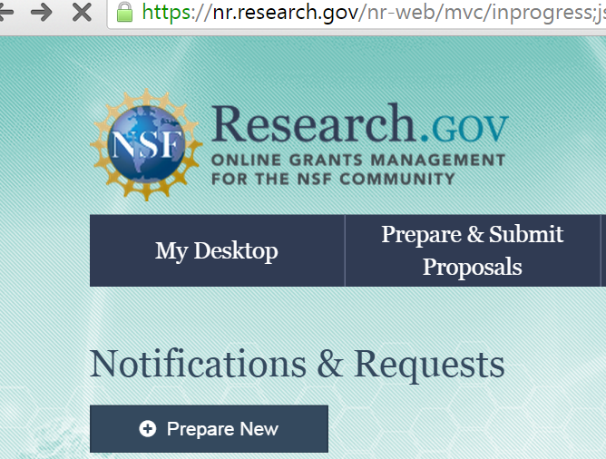

- Select “No-Cost Extension”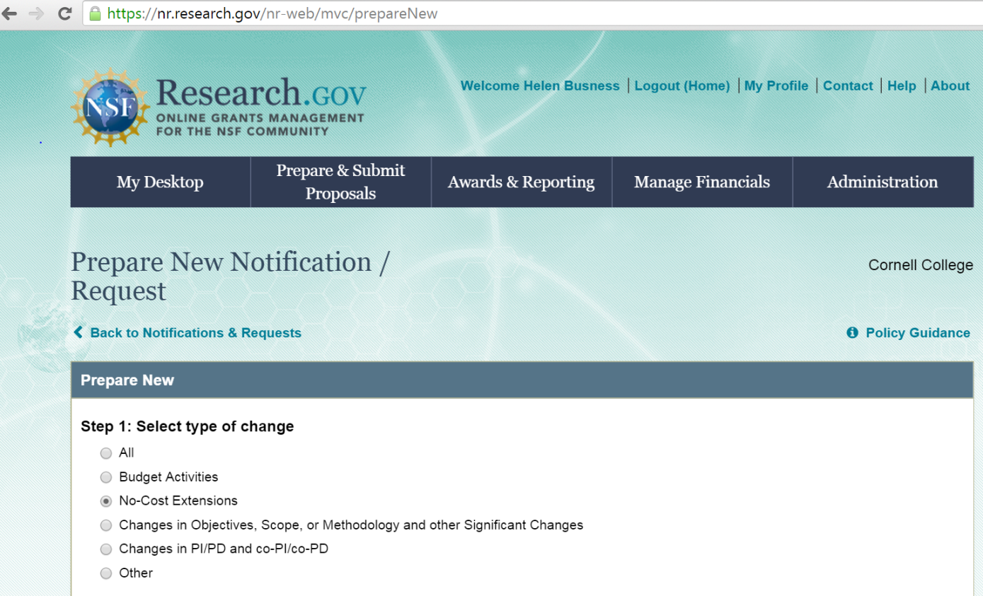
- This generates an e-mail to AOR (Authorized Organizational Representative). AOR must enter Research.gov, Awards and Reporting, and approve request.

